1. **Connection Scheme of Inverter Below 6kW**

**to Low Voltage Battery RW-M6.1**

**·Single Inverter**

|  |  |  |
| --- | --- | --- |
| Number of Battery Pack(s) | Number of Pcables | Number of Bcables |
| 1 | 1 | / |
| 2 | 1 | 1 |
| 3 | 1 | 2 |
| 4 | 1 | 3 |
| ... | 1 | N-1 |

Remarks：1.N is the number of battery packs.

2.Bcable (for battery parallel) can be adapted from Pcable (connect with hybrid inverter) and the fast plug that comes with the battery pack.

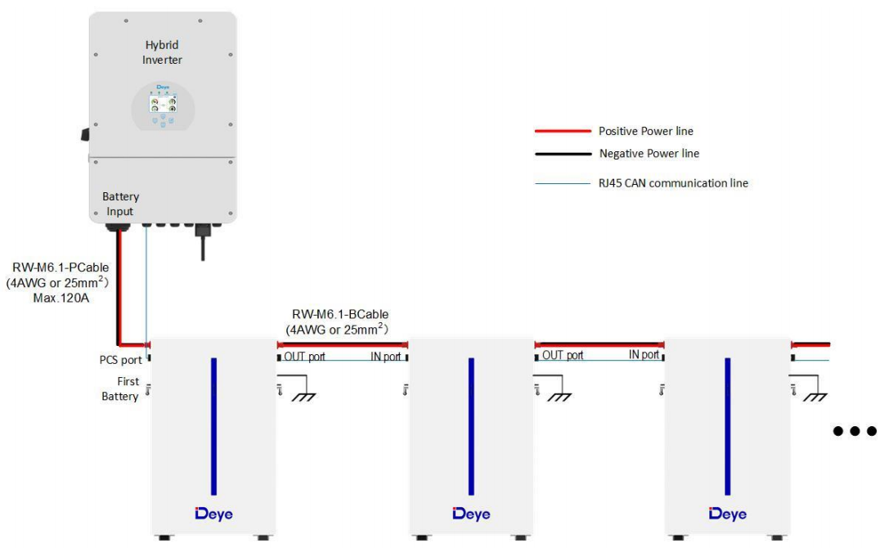

**·****Multiple Inverters**

|  |  |  |
| --- | --- | --- |
| Number of Battery Packs | Number of Pcables | Number of Bcables |
| 2 | 2 | / |
| 3 | 3 | / |
| 4 | 4 | / |
| ... | N | / |

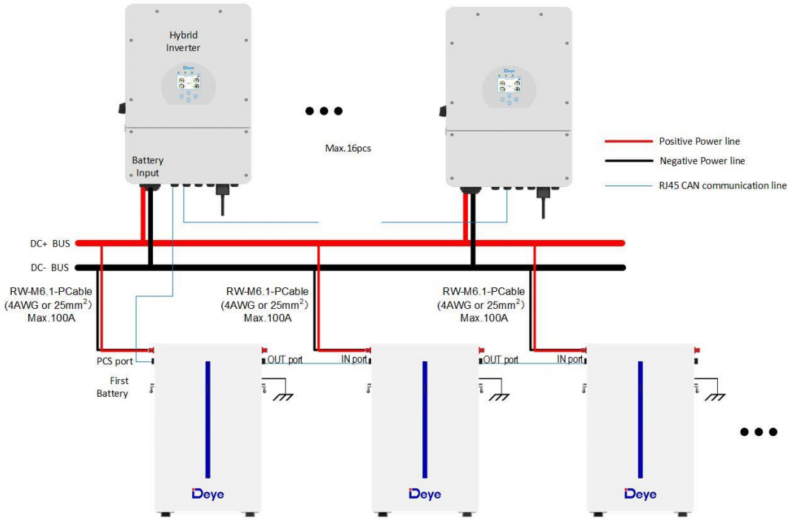

1. **Connection Scheme of Inverter Above 6kW**

**to Low Voltage RW-M6.1 Battery**

**·Single Inverter**

|  |  |  |
| --- | --- | --- |
| Number of Battery Packs | Number of Pcables | Number of Bcables |
| 1 | 1 | / |
| 2 | 2 | 1 |
| 3 | 2 | 2 |
| 4 | 2 | 3 |
| ... | 1 | N-1 |

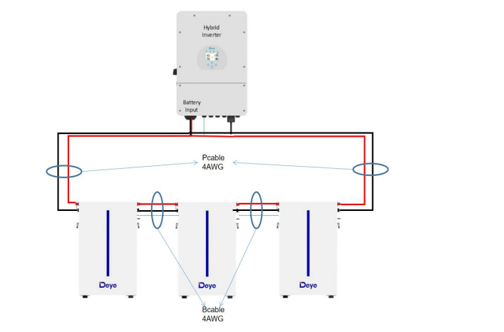

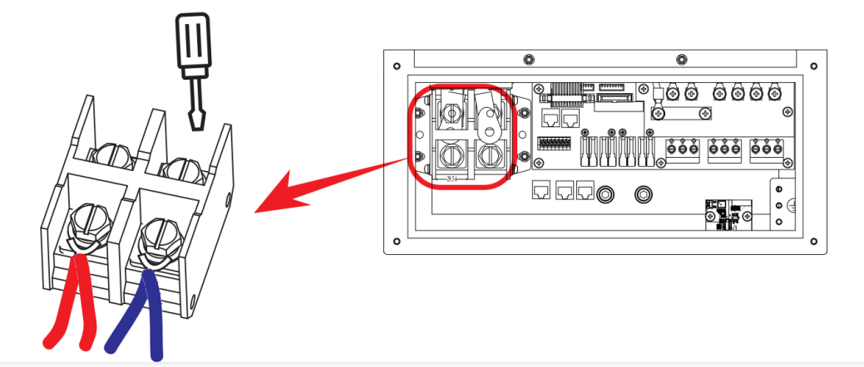

**·Multiple Inverters**

|  |  |  |
| --- | --- | --- |
| Number of Battery Packs | Number of Pcables | Number of Bcables |
| 2 | 2 | / |
| 3 | 3 | / |
| 4 | 4 | / |
| ... | N | / |

